Міністерство освіти і науки України

Харківський національний університет радіоелектроніки

Факультет комп’ютерних наук

Кафедра програмної інженерії

**АТЕСТАЦІЙНА РОБОТА**

**Пояснювальна записка**

бакалавр

(освітньо-кваліфікаційний рівень)

«Програмна система автоматизованого прогнозування вартості програмного продукту при його модифікації»

(тема)

Виконала: студентка 4 курсу, групи ПІ-13-1

напряму підготовки

6.050103 – Програмна інженерія

Лук’янова К. Ю.

Керівник доц. Ворочек О. Г.

Рецензент проф. Бондарєв В. М.

Допускається до захисту

Зав. кафедри ___________ Дудар З.В.

(підпис)

2017 р.

Харківський національний університет радіоелектроніки

Факультет *комп’ютерних наук*

Кафедра *програмної інженерії*

Освітньо-кваліфікаційний рівень *бакалавр*

Напрям підготовки ____ *6.050103 – Програмна інженерія*

ЗАТВЕРДЖУЮ:

Зав. кафедри ______________

(підпис)

«_____»________________ 2017 р.

**ЗАВДАННЯ**

НА АТЕСТАЦІЙНУ РОБОТУ

студентові *Лук’яновій Катерині Юріївні*

1. Тема роботи (проекту) «Програмна система автоматизованого прогнозування вартості програмного продукту при його модифікації»,______________________________________

затверджена наказом по університету від "*16*"__*травня*__2017р. № _*535Ст____*

2. Термін подання студентом роботи (проекту) ______8.06.2017 р.____________________

3. Вихідні дані до роботи (проекту) _*електронні ресурси за обраною тематикою,_______ мінімальні вимоги до функціональності програми, загальні вимоги до архітектури______ системи._____________________________________________________________________*

*_____________________________________________________________________________*

4. 3міст пояснювальної записки (перелік питань, що потрібно розробити) *вступ, аналіз__ проблемної області і постановка задачі, опис об'єктних моделей, використовувані______ методи та алгоритми, опис розробленої програмної системи, аналіз можливих________ застосувань*.__________________________________________________________________

_____________________________________________________________________________

5. Перелік графічного матеріалу (з точним зазначенням обов’язкових креслеників,

плакатів) *_постановка задачі, об'єктна модель системи, базові моделі, методи й_____ алгоритми, структура бази даних, приклади інтерфейсів програмної системи, висновки, слайди з презентації.___________________________________________________________*

*_____________________________________________________________________________*

6. Консультанти розділів роботи

|  |  |  |  |
| --- | --- | --- | --- |
| Найменування  розділу | Консультант  (посада, прізвище, ім’я, по батькові) | Позначка консультанта  про виконання розділу | |
| підпис | дата |
| Спецчастина | доц. Ворочек О.Г. |  |  |
|  |  |  |  |
|  |  |  |  |

7. Дата видачі завдання 18.04.2017р________

**КАЛЕНДАРНИЙ ПЛАН**

|  |  |  |  |
| --- | --- | --- | --- |
| № | Назва етапів роботи | Термін  виконання етапів проекту (роботи) | Примітка |
| 1 | Аналіз предметної області | 18.04.2016 - 26.04.2016 | виконано |
| 2 | Розробка схеми БД | 27.04.2016 - 02.05.2016 | виконано |
| 3 | Розробка алгоритмів | 03.05.2016 - 07.05.2016 | виконано |
| 4 | Створення коду | 07.05.2016 - 23.05.2016 | виконано |
| 5 | Тестування програми | 23.05.2016 - 26.05.2016 | виконано |
| 6 | Підготовка пояснювальної записки. | 20.05.2016 - 01.06.2016 | виконано |
| 7 | Підготовка презентації та доповіді | 27.05.2016- 01.06.2016 | виконано |
| 8 | Попередній захист | 01.06.2016 | виконано |
| 9 | Нормоконтроль, рецензування | 01.06.2016 | виконано |
| 10 | Занесення диплома в електронний архів | 01.06.2016 | виконано |
| 11 | Допуск до захисту у зав. кафедри | 06.06.2016 |  |

Студент ___________________________________ Лук’янова К. Ю.

(підпис)

Kepiвник роботи ___________________ доц. Ворочек О.Г.

(підпис)

РЕФЕРАТ/ABSTRACT

Пояснювальна записка: 56 с., 21 рис., 15 джерел, 4 додатка.

Мета роботи – створення програмної системи автоматизованого прогнозування вартості продукту при його модифікації.

Методи вирішення – концептуальне моделювання предметної області, використання об’єктно-орієнтованого підходу до створення програмного додатку. Для розробки обрано мову програмування Python, середовище PyCharm 2017.

Результат роботи – додаток, який дає змогу полегшити процес обліку вартості програмного продукту та частково автоматизувати його.

БАЗА ДАНИХ, PYTHON, DJANGO, AGILE, CHANGE REQUEST, SQLITE, ВАРТІСТЬ, ПРОГРАМНИЙ ПРОДУКТ.

The aim is to create software of the automated forecasting of changes in product's value under its modifications.

Solution methods are conceptual modeling of the domain, using an object-oriented approach to building software applications. The programming language Python, technology and environment PyCharm 2017 were chosen for implementation.

The result – an application that allows you to facilitate accounting of funds that will be spent on product after its modifications and also partially automate this approach.

DATABASE, PYTHON, DJANGO, AGILE, CHANGE REQUEST, SQLITE, VALUE, SOFTWARE.

TABLE OF CONTEST

Introduction 6

1 Analysis of subject area and problem statement 8

1.1 Theoretical basis 8

1.2 Analogue analysis 10

1.3 Problem statement 13

2 Scope of requirements for software application 14

2.1 Development purpose 14

2.2 Software requirements 14

2.3 Client requirements. 16

3 Description of object models, methods and algorithms, the database structure…………………17

3.1 Analysis and conceptual modeling of the subject area 17

3.2 UML- modeling system 20

3.3 Database designing 22

3.4 Development of the algorithm for estimation projects value 24

4 Description of software implementation 26

4.1 Description of physical database model 26

4.2 Description of database maintaining functions 28

5 Research and analysis of exploitation and possible usage of application 35

5.1 Analysis of possible usage of application 35

5.2 Description of system testing 36

Conclusions 37

References 38

Appendix А – Presentation slides 40

Appendix B – Abstracts 48

Appendix C – Parts of code 52

Appensix D – Electonic materials (CD)

INTRODUCTION

Nowadays in IT industry more and more projects, startups and variety of products are being developed, but not all of them are successfully released. In term of project success, is the product that is completed on time and on budget, delivering the expected value. The main reason of failure projects is poor cost estimation. As software costs estimation is inherently difficult, and humans are terribly bad at predicting absolute outcomes. No two projects are the same: each is unique in what it sets out to achieve. Often, when appears a simple problem during development it is much harder or technically challenging to implement it without cost changing. Undoubtedly, there will be ‘unknowns’ with the project that can only be identified when they arise. [7]

Moreover, no two people are the same, whether you are a customer, a developer or a user. We come preloaded with our own set of knowledge, experiences, values, expectations, attitude to risk, and ability to adapt.

From this, we can see that accurate product cost estimating is very important. Underestimated budget may convince management to develop new systems that later over run their budgets and fail to achieve their expected payoff. Many worthwhile projects are cancelled because of cost overruns due to poor estimates. This way company loses its profit in both aspects: future cooperation with client and unreleased product. [8]

On other hand, overestimated costs may convince management not to develop potentially beneficial systems. When estimators predict unrealistically high costs beyond the maximum permitted to justify a new system with major benefits, management generally declines to approve it and thus loses those potential benefits.

In order to plan the budget for a project, many costs are not known in advance. This way forecasting is used in order to estimate what these costs will be. Forecasts can never be completely accurate, but can provide a good idea of what to expect if the appropriate techniques are used. Some forecasting techniques are less accurate than others are but are used to start planning. When more detailed data becomes available, more accurate forecasting techniques can be used. The aim of this work is to create software of the automated forecasting of changes in product's value under its modifications.

In the forecasting budget process, the cost of each project activity is estimated. In forecasting budget process, the cost of each activity is determined, including the cost of human hours, the cost of equipment, and the cost of materials used as well as the contingency cost (i.e. the cost to cover the identified risks). [15]

During graduation work was designed and developed a system that has become a handy tool for sales managers for one of outsource companies for estimating budget for upcoming project or feature. The program allows sales managers to choose different resources or activities that should be included during developing new project or feature, as in forecasting budget application, the cost of each activity is determined, including the cost of human hours, the cost of equipment, and the cost of materials. Moreover, there is a possibility to add new categories and activities if company does not faced with that request or functionality before. Thus, it is easy to expand application’s functionality. Also there is a possibility to keep records of all projects or change requests that were made to one of clients. The software also allows the system to forecast the value of developed feature by estimating it in bottom-up technique.

Presentation is one of the results of graduation work (see. Appendix A).

In addition, there were given abstracts to polish journal of Science and Practice. Abstracts are given in Appendix B. Listing code is shown in Appendix C. All content is written to disk (see. Appendix D).

1 ANALYSIS OF SUBJECT AREA AND PROBLEM STATEMENT

1.1 Theoretical basis

A recent Harvard Business Review article revealed that one in six IT projects has a cost overrun of 200%.  That is a pretty high rate of failure for estimation. To minimize the risk of having your next technical project go awry, stop estimating and start budgeting. [14]

When creating a budget for a project, project management must be able to engage properly in the process of cost estimating. This is a calculated projection of the cost for the materials required by the project. The materials considered in cost estimating can be any resources required for the job such as raw materials or employee wages.

It is critical for a true approximation of the production costs that those in project management take into account all resources, which might be used. Neglecting certain materials could result in cost estimating which is too low. This increases the likelihood that the budget will be exceeded.

Accurate cost estimating by project management needs to be done often when creating a bid for the project. Too high of an estimate, and the bid could be lost to another company. A bid which is falsely low will result in unanticipated costs the client will have to pay, and that could damage the chances of future business with that customer. Knowing the true price of the project is important for anyone in management in order to create a budget for the job and to make bids.

Nowadays used a lot of techniques and methods to forecast project’s or change request’s value. In diploma work will be described only two of them.

Analogous estimating is a technique for estimating a variety of project parameters and measures of scale. The project parameters that can be measured include those of project cost, project budget, scope of the project, and expected project duration. The project measures that can be estimated using this technique can range from the size of the project, to the project weight, to the complexity. The estimates are made by comparing the current activity to that of a smaller activity that took place previously and drawing comparisons in proportion to that. It is frequently used to estimate the size of a particular parameter when information as to that particular parameter within the current project is limited or unavailable until a later date. Analogous estimating is typically a form of expert judgment that is most reliable not only when the previous activities are similar to the current activity in fact, and not just in appearance, and also is traditionally most effective when the team members preparing the estimates have the expertise necessary to accurately do so. [12]

Bottom-up estimating is an extremely helpful technique in project management as it allows for the ability to get a more refined estimate of a particular component of work. In bottom-up estimating, each task is broken down into smaller components. Then, individual estimates are developed to determine what specifically is needed to meet the requirements of each of these smaller components of the work. The estimates for the smaller individual components are then aggregated to develop a larger estimate for the entire task as a whole. In doing this, the estimate for the task as a whole is typically far more accurate, as it allows for careful consideration of each of the smaller parts of the task and then combining these carefully considered estimates rather than merely making one large estimate which typically will not as thoroughly consider all of the individual components of a task. In general, the smaller the scope, the greater the accuracy. [12]

A well-researched and planned cost estimation and budget is necessary for the successful completion of any project. Project managers need to thoroughly scope the project in order to secure sufficient funding. Scoping involves estimating labor hours, materials, supplies and other miscellaneous expenses. Cost estimations and budgets are a work in progress and should contain room for change.

A good cost estimate is unbiased. It should not be made by someone who would over- or under-state the numbers. The cost estimate should clearly define the purpose of the project, what it will accomplish, what assumptions are made, how long the estimate is valid, and how much the project will cost. It should show all interested parties everything relevant, without holding back information. The estimate should be flexible, adaptable and provide a range of the costs involved. Cost estimates start out broad, and as various stages are completed, they are more accurately define

Nowadays, in IT industry an effective and simple way to estimate costs and prepare a project budget is to use project management software. Most software has features that identify the types, quantities, and phasing of different types of labor. It also has capabilities for estimating the costs for individual project pieces and adding them together to reach a project total. The pieces can differ in size and number from a few large phases of a project with known costs to hundreds or thousands of small tasks. [11]

Management needs to assess the accuracy of cost estimates and budgets. Unanticipated expenses can result in the project being abandoned. Cost estimates that are overstated also have negative consequences. If they are too liberal, they can kill an otherwise viable project by making it look unaffordable. Good cost estimating requires access to a historical cost database. For example, in the software industry, there should be a cost database that contains information regarding cost per line of code, software sizing algorithms and costs for functional descriptions and tasks.

Not scoping the project thoroughly enough, misunderstanding technical difficulties, and making changes are the most common reasons projects do not adhere to cost estimates and budgets. Cost estimates can never be too detailed. Every change should be documented thoroughly. Management should consider how changes affect other phases of the project. A simple, yet effective tool is to use a spreadsheet to prepare the cost estimate, and keep all of the important data visible in cells, instead of hidden in formulas.

1.2 Analogue analysis

Nowadays, there is a variety of applications that allow user approximately estimate budget for his application. There are many user-friendly calculators of application cost.

One of such applications is VenturePact web application. It quickly estimates the cost of developing an iPhone, Android or hybrid mobile app. User should just answer 10 simple questions about his app. But, the main drawbacks are that user can estimate only mobile applications and these estimates do not describe the whole picture.

There is no possibility to add new categories or features that should be presented in application by client’s needs. Moreover, it has not variety of choice that can be implemented in application.

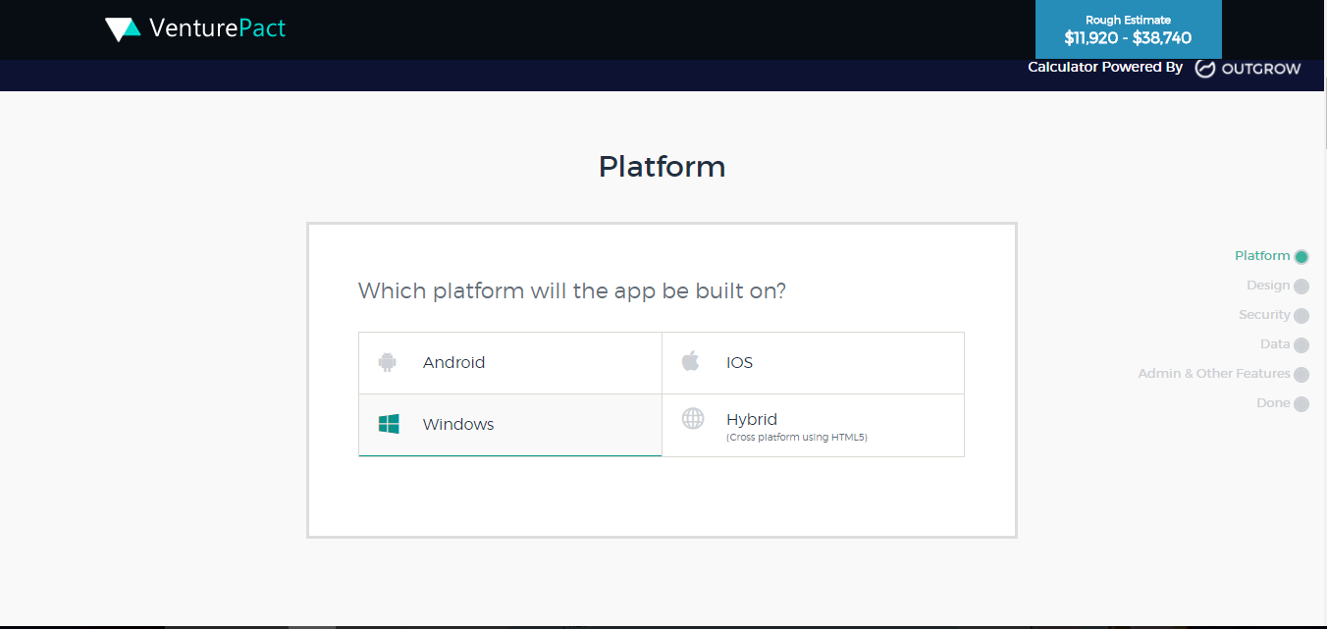

Picture 1.1 – Interface of VenturePact application

Another one application is Estimator desktop application. Estimator Application is, as the name implies, an estimating application.

It’s a program with a basic interface and just enough functionality to get the job done.

Some features include:

1. Default cost library;
2. Option to import and export cost libraries to and from Excel;
3. Cost calculations;
4. Proposal generator.

This application works very well for estimating large jobs, but a simple spreadsheet program would be more time efficient for very small projects Moreover, from one hand, learning how to use Estimator Application can be a time consuming process, but on the bright side, it is free of cost.

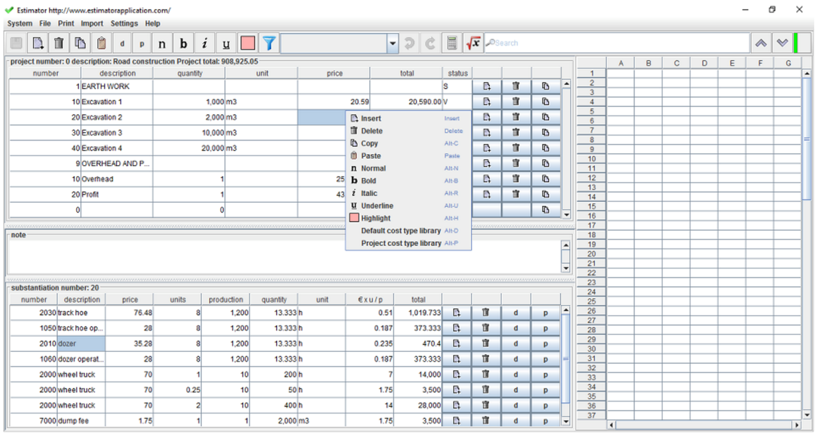

Picture 1.2 – Interface of Estimator application

It is well suited for a small construction business ready to transition from spreadsheets or paper and pen to software-supported estimating.

The point is that analogues that were previously mentioned are free of charge. Free software is a great choice for many construction contractors — especially those using software for the first time. However, as job volume increases, paid software often becomes the better choice.

Higher job volume and company growth means more people, processes and training are necessary to estimate and complete projects. Paid software typically offers more “out-of-the-box” functionality than free software, as well as training, support and integration with other critical applications, such as accounting and project management software.

Fortunately, there are affordable estimating and takeoff products that also offer free trials. With a free trial, you can try before you buy and avoid purchasing a product estimators do not like.

1.3 Problem Statement

The aim of graduation paper is to develop software of the automated forecasting of changes in product's value under its modifications. This software application should have a possibility for estimating projects cost from the beginning or by creating change request. There will be also the functions of adding new categories if company did not implement such solutions before. To forecast the project’s value by using bottom up methods. For ease of analysis necessary to add the ability to edit total budget by editing some of categories. Also, as it will be Web application, there is possible to work with the application on different devices and places.

The software that will be developed, should have the following functionality:

1. authorization & authentication;
2. estimate new project or change request;
3. chose technologies and types of project;
4. chose development types;
5. chose human resources and their rates;
6. chose time & material;
7. chose additional options for project/change request creation;
8. create new feature that should be implemented;
9. edit total budget by excluding or including any categories;
10. save project budget estimation;
11. review history of all change requests that were made to selected project;
12. cross browser (Google Chrome, Mozilla Firefox 2 latest version).

At the analysis stage, goals are set; the requirements for the database are defined. They consist of general and specific requirements.

Building a conceptual model usually takes place in two stages. The first stage is to collect and analyze performance data and build models so-called local representations. Most local model reflects the idea of ​​a single user. Sometimes this model can describe some independent data area or several functional tasks (multiple applications). It must be noted that the design concepts of individual users reduces the level of data integration and modeling of common representations of users - to increase the complexity of the design [1]. In this regard, by selecting of data for local simulation it should be chosen a compromise between the above options. First of all, the essence should be determined in developing a conceptual model. Finding essence, you should determine which connections are between them. Next step is to determine the type of connections. In the second stage, built local models are combined into a generalized conceptual model.

When developing a database schema should be remembered that the specificity of a particular database might include restrictions on naming database objects, constraints on the supported data types, etc. In addition, the specificity in the specific database physical design includes selection decisions related to the physical storage medium (choice of disk storage management, sharing files and databases on the devices, methods of data access), creating indexes, etc.

To implement the support plan appropriate algorithms should be developed and decided according to what information should be considered in the calculations.

During graduation work such issues should be resolved:

1. conduct an analysis, UML and conceptual domain modeling;
2. develop a database schema;
3. develop algorithms for forecasting estimation of project value under its modifications;
4. implement software application of estimation project’s value under its modifications.

The program should meet the essential requirements that apply to software products (stability, data protection in their introduction, the optimal use of resources). The user interface must be intuitive, user-friendly and ergonomic.

The color scheme in the software product will meet the basic principles of design interfaces and provides for standard items. The user will not have to adapt to the various features of the software.

For software development was chosen Python, because this language was considered optimal for developing software such specifics, because it provides the ability to create software with the implementation of full functionality.

2 SCOPE OF REQUIREMENTS FOR SOFWARE APPLICATION

Before beginning development the software system, it is necessary to define the requirements for it. In general meaning, the requirements are the set of properties that should have a system that is going to be implemented. In the graduation work there is going to be implemented software application, which will simplify and automate parts of forecasting estimates for products value under its modifications.

2.1 Development purpose

The software application is designed for sales managers, project managers for one of IT companies to quickly forecast on-site estimates for products value under its modifications. Accurately estimating project costs is crucial to staying within budget. Get estimate wrong and company could end up in the red or even unable to complete the project. Accurately calculating project costs requires detailed planning and accurate information, plus the ability to foresee potential complications. The same process applies whether the project is building a new website or a multi-story office building. The software application should allow users to get a rough idea of what it will take to change some features in product. It also should have capabilities for estimating the costs for individual project pieces and adding them together to reach a project total. The pieces can differ in size and number from a few large phases of a project with known costs to hundreds or thousands of small tasks. Such categories should be a part of estimation as material, labor and other costs needed to complete a construction project. In addition there should be a possibility to do all the calculations, so once all the data is entered in, the user will get the total estimated project cost. This application suits for management needs to assess the accuracy of cost estimates and budgets.

2.2 Software requirements

The general information about the development of the system is following: software of the automated forecasting of changes in product's value under its modifications should be developed by using the Python programming language, using the Django framework. Django was chosen as this web application framework is basically a toolkit of components that all web applications need. The point of this is to let developers focus on the things that are new and unique about project instead of implementing the same solutions over and over again. Django is even more fully featured than most other frameworks, coming with everything that is needed to build a web app right out-of-the-box. Django follows the MVC design pattern. That stands for Model-View-Controller.

The model(M) is a model or representation of data. The model allows to pull data from your database without knowing the intricacies of the underlying database. The model usually also provides an *abstraction* layer with your database, so that you can use the same model with multiple databases. Model is the database handling layer defined in models.py

The view(V) is what user sees. It is the presentation layer for model. On the computer, the view is what user see in the browser for a Web app, or the UI for a desktop app. The view also provides an interface to collect user input. View is the display layer (html files).

The controller(C) controls the flow of information between the model and the view. It uses programmed logic to decide what information is pulled from the database via the model and what information is passed to the view. It also gets information from the user via the view and implements business logic: either by changing the view, or modifying data through the model, or both. [4]

Library SQLite-net was selected as the technology to work with. SQLite - the project is open source, which aims at the realization of engine operation locally stored database using SQLite data at their object models. As Django provides support for integrating static assets into a project, it was decided to use Bootstrap to this project for some basic styling. For using JavaScript in Django project was used RequireJS library, an Asynchronous Module Definition (AMD) loader. Instead of requiring to list all scripts in exactly the correct order (sometimes difficult in a template inheritance hierarchy using a large set of JavaScript files) and hoping that none of them use the same global variable in conflicting ways (definitely difficult in a language where it’s actually hard not to accidentally define new global variables), AMD allows user to explicitly list the dependencies for a module of JavaScript code.

The main functionality of developed software is:

* authorization & authentication;
* estimate new project or change request;
* chose technologies and types of project;
* chose development types;
* chose human resources and their rates;
* chose time & material;
* chose additional options for project/change request creation;
* create new feature that should be implemented;
* edit total budget by excluding or including any categories;
* save project budget estimation;
* review history of all change requests that were made to selected project;
* cross browser (Google Chrome, Mozilla Firefox 2 latest version).

2.3 Clients requirements

Software is developed as Web application. For using this software users should have laptop or tablet or mobile phone with installed browser Google Chrome or Mozilla Firefox latest version and access to Internet. No more technical requirements is not needed.

3 DESCRIPTION OF OBJECT MODELS, METHODS AND ALGORITHMS, THE DATABASE STRUCTURE

3.1 Analysis and conceptual modeling of the subject area

The aim is to review conceptual modeling domain and the creation of a conceptual model that combines the idea of ​​the contents of the database resulting from the study of the subject area. In other words, a conceptual model - a description of the database structure, which is made using natural language, tables, charts, and other means that are understandable to all people working on the design database. The main component of the conceptual model is to describe the object domain and relationships between them. Designing conceptual model based on the analysis solved in this business tasks for data processing. Conceptual model includes a description of objects and their relationships of interest in the subject area and are the result of data analysis.

Conceptual modeling is used as a way to represent the relationships of entities within a database. Whether written down via text or diagrammed visually, such a conceptual model can easily represent abstract concepts of the relationships between objects in the system, such as Users and their relationship to Accounts.

Applying these objectives to our example data model above, we can ascertain that a conceptual data model should capture the key business entities (a user, project, change request), as well as the relationships between these entities.

Every User can create different projects that could have different change requests that can be referred to one of the projects. For estimating project or change request budgets new entities should be predefined as characteristics, where user can add new items that should be also included for forecasting of projects value. As we observe estimation budget for IT project we should create also such entities as human resources for estimating how much time and value should be spent on creating feature/project by developer with Senior or Middle or Junior level. In addition, Technologies, Materials, Severity should be included as they are the main entities of increasing total cost of project or feature.

Thus, the main entities in subject area are “User”, “Project”, “Change request” “Characteristics”, “Human resources”, “Project Technologies”, “Materials”, “Severity”. Such connections were developed between these entities during conceptual model designing:

* user can create and estimate different projects that could have different change requests that can be referred to one of the projects;
* many characteristics, human resources, materials and etc. can be referred to change request;
* project is also connected to characteristics and human resources, but user can also add change requests to projects and this will change the total value of project budget.

Taking into account all connections that were found, relationship diagram was developed, that is shown on picture 3.1.

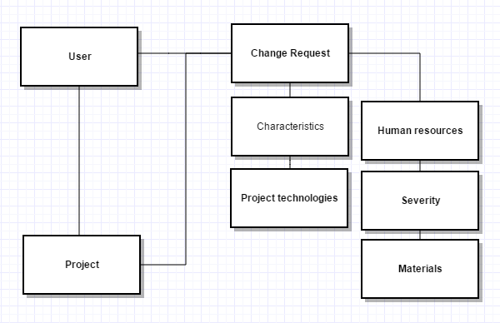

Picture 3.1 – Relationship diagram

Accept information about these entities, there also should be stored data related to information regarding type of projects as healthcare or financial project; developed requirements or testing types that can affect the total cost of project budget. Also to be able to automate the process of estimating projects value under its modifications, functionality of adding new categories should be added. This way software can be scalable and suitable for most of IT projects.

So, after analysis and conceptual design were identified, key system essences and their attributes were defined that should be basic in modeling and system development. These entities are:

* User;
* Project;
* Change request;
* Categories;
* Human resources;
* Materials;
* Project Type:
* Project Technologies;
* Severity.

“User” entity should have such attributes:

* user id that is unique identification in the system;
* e-mail for login to the system;
* password.

“Project” entity should have such attributes:

* project id – unique number in the system;
* name;
* cost;
* client name
* change request id – link to change request that is made to current project;
* category id – link to categories that should be done to current project;
* type of project;
* material id – link to material that should be used for current project;
* human resources id – link to human resources that should be used for current project;
* severity id – link to severity to see when this project should be completed;
* technology id – link to technologies that should be used for current project.

“Change request” entity should have such attributes:

* change request id – unique number in the system;
* name;
* cost;
* category id – link to categories that should be done to current change request;
* material id – link to material that should be used for current change request;
* human resources id – link to human resources that should be used for current change request;
* severity id – link to severity to see when this change request should be completed;
* technology id – link to technologies that should be used for current change request.

“Categories” entity should have such attributes:

* category id – unique number in the system;
* name;
* availability;
* description
* rate;

“Project Technologies” entity should have such attributes:

* technologies id – unique number in the system;
* name;
* rate.

“Materials” entity should have such attributes:

* material id – unique number in the system;
* type;
* rate.

“Severity” entity should have such attributes:

* severity id – unique number in the system;
* type;
* rate.

“Human resources” entity should have such attributes:

* human resource id – unique number in the system;
* grade;
* qualification;
* technology;
* hours;
* rate.

3.2 UML- designing

For more complete understanding of the program and expanded understanding of the tasks were constructed visual UML diagrams that provide a more complete description of a software product that will be created.

The Unified Modeling Language (UML) is a standard visual modeling language intended to be used for modeling business and similar processes, analysis, design, and implementation of software-based systems. UML is a common language for business analysts, software architects and developers used to describe, specify, design, and document existing or new business processes, structure and behavior of artifacts of software systems. [5]

UML can be applied to diverse application domains (e.g., banking, finance, internet, aerospace, healthcare, etc.) It can be used with all major object and component software development methods and for various implementation platforms. Based on the analysis, conceptual model and problem statement were designed UML-diagrams to facilitate the design of information systems. [10]

Use case diagram is a behavioral UML diagram type and frequently used to analyze various systems. They enable user to visualize the different types of roles in a system and how those roles interact with it. Especially Use case diagrams are useful for presenting projects to managers or stakeholders. [2]

By highlighting the roles that interact with the system and the functionality provided by the system without going deep into inner workings of the system.  (see. pic.3.2);

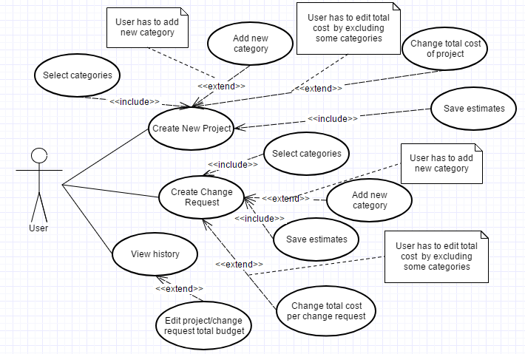

Picture 3.2 – Use case diagram

Deployment diagram is used to have a graphical representation of the infrastructure of the program that will be deployed. Deployment diagram is described on picture 3.3.

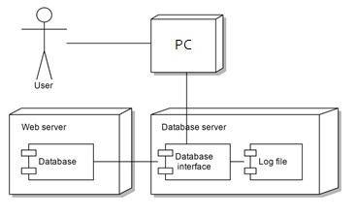

Picture 3.3 – Deployment diagram

3.3 Database designing

SQLite database was selected as data storage of developed application.

SQLite is a compact embedded relational database. Unlike most other databases, SQLite does not have a separate server process. SQLite reads and writes directly to ordinary files. The complete SQL database with multiple tables, indexes, triggers and views, contained in a single file. File format database is cross-platform. Ease of implementation is achieved by the fact that before the transaction records the entire file that stores database is locked; ACID-functions are achieved, including by creating a log file. [13]

Since SQLite database requires no administration, it works well in devices that must operate without DBA expert support.

The main entities in current system, that is developed are: “User”, “Project”, “Change request”, “Characteristics”, “Human resources”, “Project Technologies”, “Materials”, “Severity”. Attributes and connections between these entities should be defined.

During the conceptual modeling was found that "User" has the following attributes: a unique user number in the system; e-mail; password. “Project” entity should has such attributes:

project id – unique number in the system; name; cost; client name; change request id – link to change request that is made to current project; category id – link to categories that should be done to current project; type of project id – link to type of project table; material id – link to material that should be used for current project; human resources id – link to human resources that should be used for current project; severity id – link to severity to see when this project should be completed; technology id – link to technologies that should be used for current project.

“Change request” entity has such attributes: change request id – unique number in the system; name; cost; category id – link to categories that should be done to current change request; material id – link to material that should be used for current change request; human resources id – link to human resources that should be used for current change request; severity id – link to severity to see when this change request should be completed; technology id – link to technologies that should be used for current change request.

“Categories” entity has such attributes: category id – unique number in the system; name; availability; description; rate. “Project Technologies” entity should have such attributes: technologies id – unique number in the system; name; rate. “Materials” entity should have such attributes: material id – unique number in the system; type; rate. “Severity” entity should have such attributes: severity id – unique number in the system; type; rate. “Human resources” entity should have such attributes: human resource id – unique number in the system; grade; qualification; technology; hours; rate.

Thus, based on the analysis database diagram was designed that is described on picture 3.4.

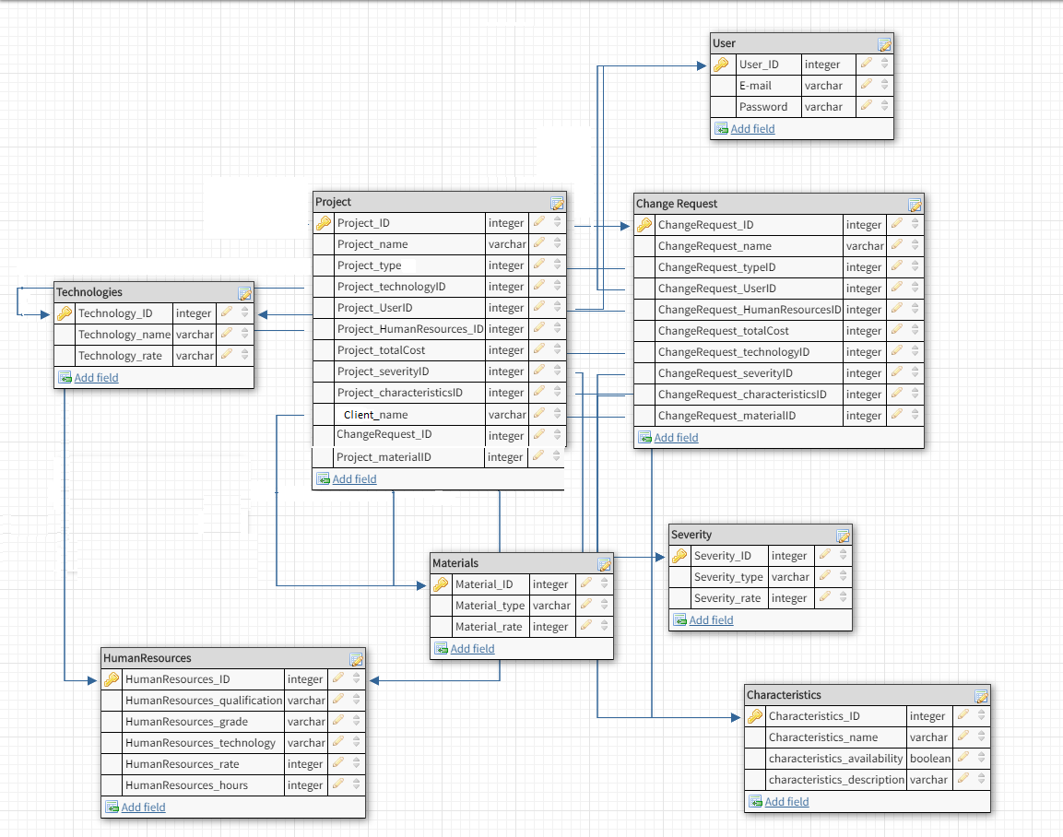

Picture 3.4 – Database scheme of main objects

The diagram shows all fields that can used by objects, relations, and also indicates what fields should be primary.

3.4 Development of the algorithm for estimation projects value

Nowadays used a lot of techniques and algorithms to forecast project or change request value. However, it takes a long time to forecast all items that will be included by making change request. This way in IT companies use special software that can estimate total value of projects under its needs and modifications.

Bottom-up estimating is an extremely helpful technique in project management as it allows for the ability to get a more refined estimate of a particular component of work. This method is a baseline of algorithm that was developed during graduation work. In bottom-up estimating, each task is broken down into smaller components. Then, individual estimates are developed to determine what specifically is needed to meet the requirements of each of these smaller components of the work. The estimates for the smaller individual components are then aggregated to develop a larger estimate for the entire task as a whole. In doing this, the estimate for the task as a whole is typically far more accurate, as it allows for careful consideration of each of the smaller parts of the task and then combining these carefully considered estimates rather than merely making one large estimate which typically will not as thoroughly consider all of the individual components of a task. In general, the smaller the scope, the greater the accuracy.

Process of project or change request estimating includes several steps. First of all, it should be confirmed what type of request should be added – either it is totally new project or it is new feature for existed project. All calculations should include all categories that are affected by developing new feature or project. For accuracy of all subsequent operations, funds should be transferred to the one currency. On based information it will be obvious how much efforts and money will take developing of new project or feature. If the total amount will not satisfy the client, user of this application can make some changes by including or excluding new categories.

Diagram of estimating algorithm is described on picture 3.5.

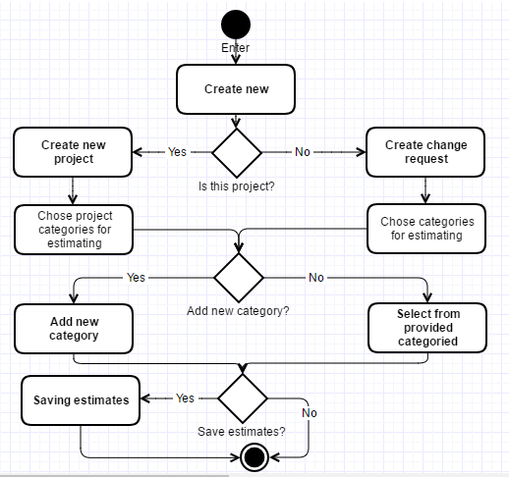

Picture 3.5 – Estimating algorithm

After entering the system, first of all, user adds – either totally new project or new change request for existed project. After what he choses, he selects categories that are affected by developing new feature or project. If there is no such category in the system, user has an availability to add new one and add rate for developing of this. By adding new categories, user can easily include all items that should be done. For accuracy of all subsequent operations, funds should be transferred to the one currency. On based information, it will be obvious how much efforts and money will take developing of new project or feature. After adding all features and categories user can save estimates to the system or quit without any savings.

4 DESCRIPTION OF SOFTWARE IMPLEMENTATION

4.1 Description of physical database model

SQLite database was selected as data storage of developed application. As SQLite is a very light weight database. Therefore, it is a very good choice for developing Django applications.

Data storing is very easy and efficient in SQLite. SQLite can be used as a temporary dataset to do some processing on some data within an application. In SQLite database, data query is very easy. Only load the data into a SQLite in-memory database and fetch the data whenever you want. User can extract the data in the way you want back to your application.

SQLite provides an easy and efficient way to deal with data rather than do the data processing internally inside in-memory variables. It does not require any installation and configuration. Just copy the SQLite libraries in your computer and is ready for creating the database. [13]

The physical model contains information about all database objects, indicating the data types that are resolved to adhere to. In addition, it indicates what fields are primary keys, and what are foreign key to maintain referential integrity, which will be provided through the application code. The main information that is saved in data base, connected to project and change request tables and categories that helps to identify how much money will be spend on developing such feature or project.

User can have many projects or change request. For all unique key fields, identificators were added, it provides auto incrementing function.

The general scheme of database with data types selected for a physical model is described on picture 4.1.

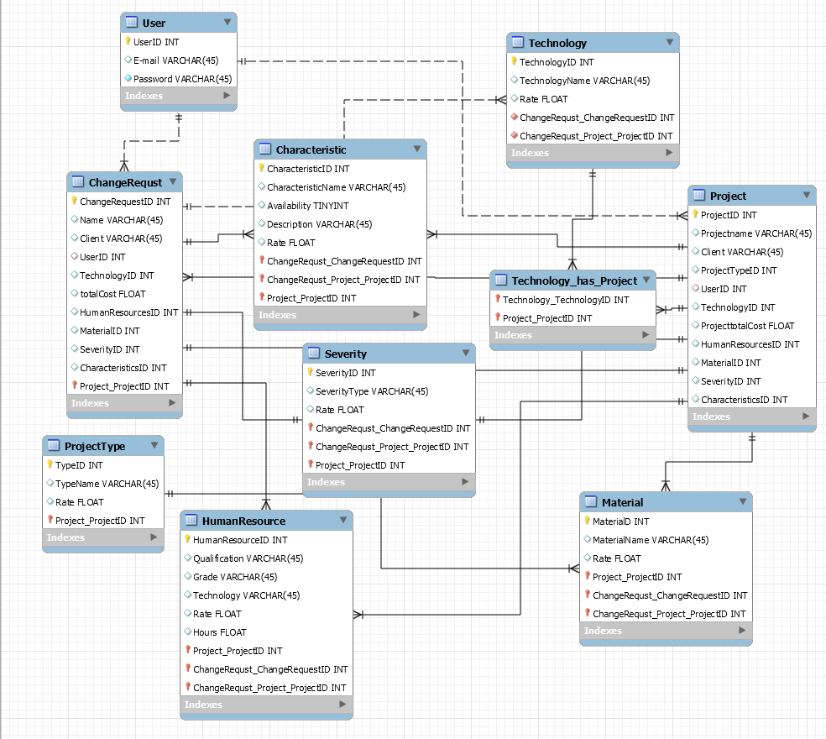

Picture 4.1 – Physical database model diagram

Foreign keys in SQL are used to enforce relationships between tables to maintain up date to date. In this case this is provided directly in the code. Unlike the majority of other database engines, SQLite has strict typing of stored data. This is done in order to ensure maximum compatibility SQL-query syntax with other SQL-engines. For this project, it was decided to adhere to these types of data collection fields:

* all identifiers has numeric data type (non-negative integer);
* text descriptions, names (name), username and password have text data type;
* the funds have a numeric data type with floating point;
* availability of category has a boolean type.

4.2 Description of functions of database maintenance

Software application was developed by using Python language and Django framework. Bootstrap framework was used for creation UI UX for this application. Bootstrap is the most popular HTML, CSS, and JS framework for developing responsive, first projects on the web. Bootstrap easily and efficiently scales websites and applications with a single code base, from phones to tablets to desktops with CSS media queries.

The main functionality of the developed system is the ability to estimate a budget for new project or to change request of existing project and also to save information about costs and hours, information on resources and technologies for the estimating of funds for various projects. Therefore, description of the interface mostly devoted to this functionality. Code Listing is shown in Appendix B.

First of all, after opening web application, user is redirected to the authorization page. There he should to enter his e-mail and password to login to the system. There is also an option as forgot password. If user click there, he will be redirected to the page, where he can leave request regarding forgotten password for admin helpdesk. As this system is developed for one of IT companies, such services have the same authentication for all corporate applications. This way there is no functionality of account creation. It is supposed that credentials have been created automatically when sales manager was hired to that company (see pic.4.2).

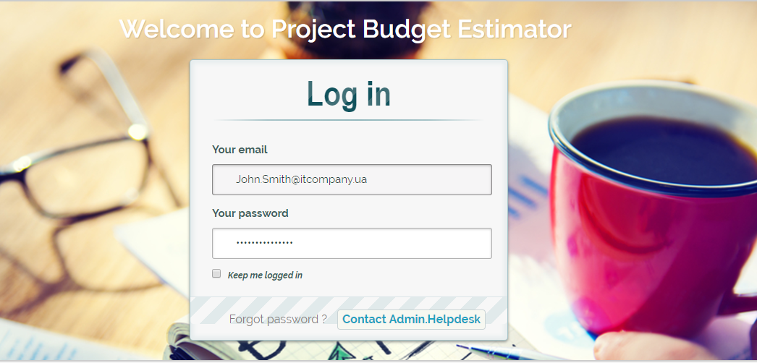

Picture 4.2 – Authentication form

After login to the web application, user has a possibility to estimate project cost for new project or for change request. (see pic. 4.3)

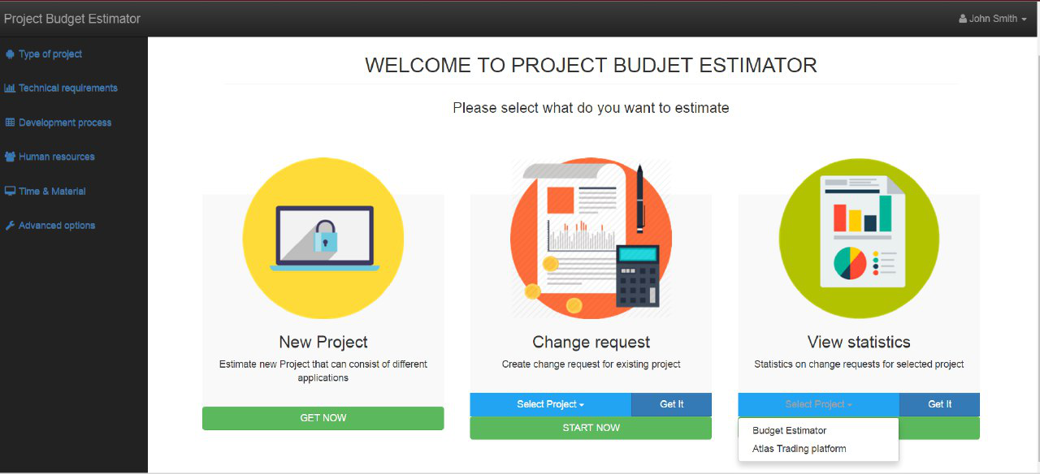Picture 4.3 – Main page of project

In addition, there is an option to see history of created projects and change requests only by that user. Moreover user has a possibility to check statistics on how many projects are financial or healthcare. More information about statistics will be highlighted on related step. Then these options will be available in account settings from every page. (see pic. 4.4).

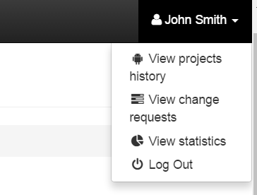

Picture 4.4 – Main page of Project budget estimator application

Thus, user has availability to see projects, change request history, statistics from anytime.

After user chose what he wants to create (i.e. create new project), he will be redirected to new page, where he supposed to select Project’s type: Financial, medical, Telecom, Trading or E-learning. After he clicks on one of items - chosen item will be highlighted (see pic. 4.5). 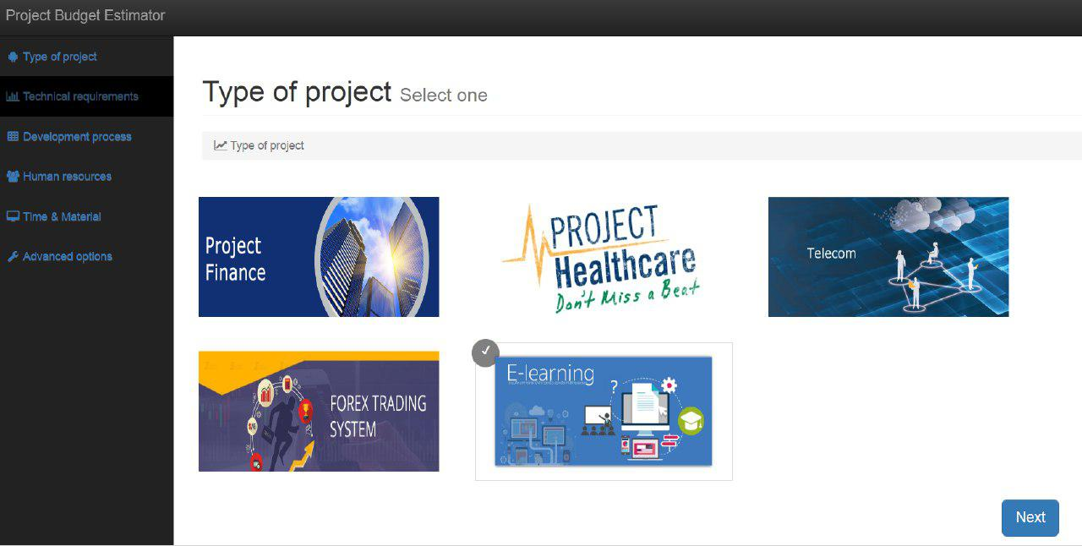

Picture 4.5 – Window of choosing type for new project

Each item has its own rate. After choosing it and pressing next – rate for selected item – will be added automatically for total cost. Next step is to click on Next button and user will be redirected to the page with Project technologies. On that page user should select system requirements, for example if it should be Web application or mobile one, what platforms: Android or IOS it should support, should his project have desktop version or not. In addition, if user wants the mobile game application or Internet of things, there is also a possibility to choose this from that page. (see pic. 4.6)

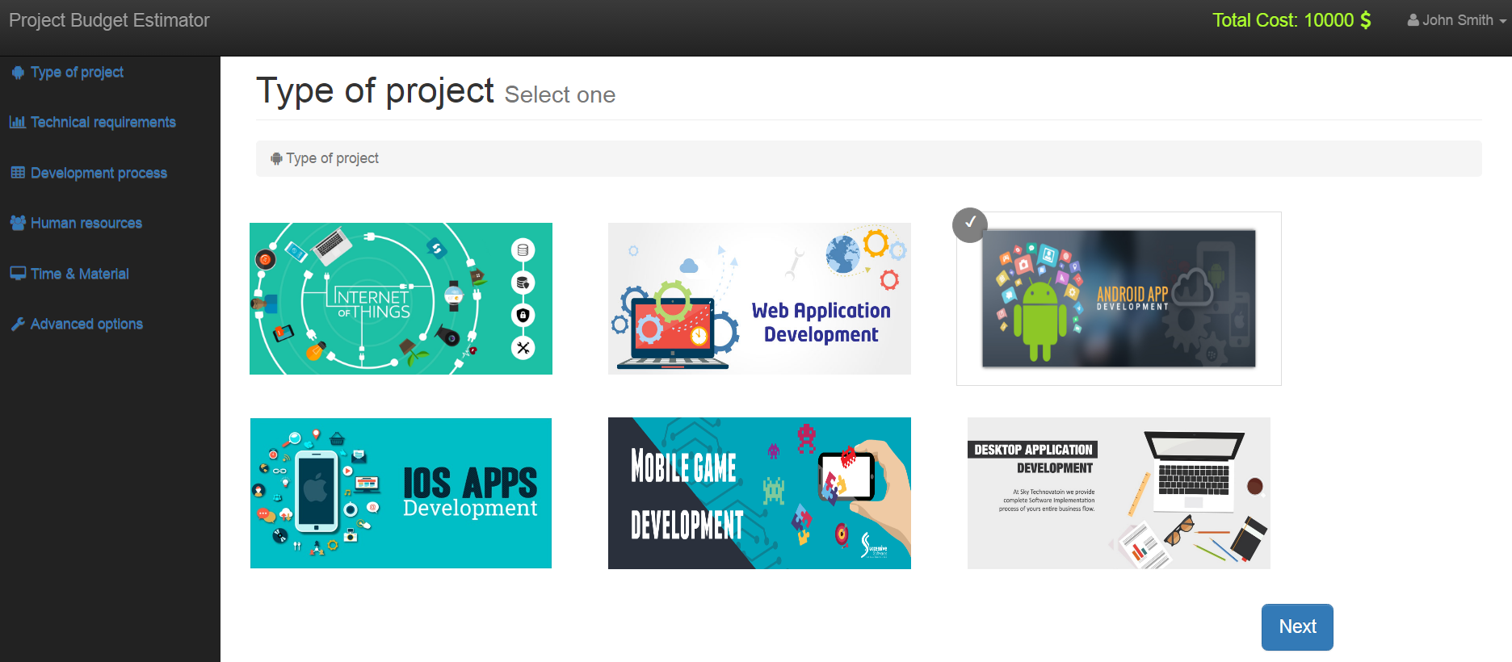

Picture 4.6 – Window of choosing technologies for new project

As one project can have many technologies, this functional was developed as checkboxes. For now, that application supports only those types of technologies.

After user submits his choice on previous step, he will be redirected to the Human resources page. Here he is supposed to select developers, business analytics, quality assurance, tech leads, project managers and other resources that should be involved for developing current project. Here user can change the total amount of projects’ value. Human resources in terms of one qualification can have different salary per hour. It is depending on grade that selected resource has. For now, we have Junior, Middle Senior grades. Also as there are different programming languages as Java, .Net, JavaScript, Python and so on, the cost of that human resource is also depends on this. Moreover, there are different types of testing like automated and manual or general that includes both automated and manual types. From this cost of quality assurance hours can be different. However, if user select juniors he should to understand that time that will be spend on work on that task will be increased. System has the rates that includes type of technology and seniority of the human resource. After user selects how many hours that resource is supposed to be included in developed project, application automatically makes calculations and shows to the user total cost of chosen human resource. It also will be visible at that page and in the end. This way if user wants to make project as soon as possible it is better to select seniors than juniors on complex tasks. (see pic. 4.7)

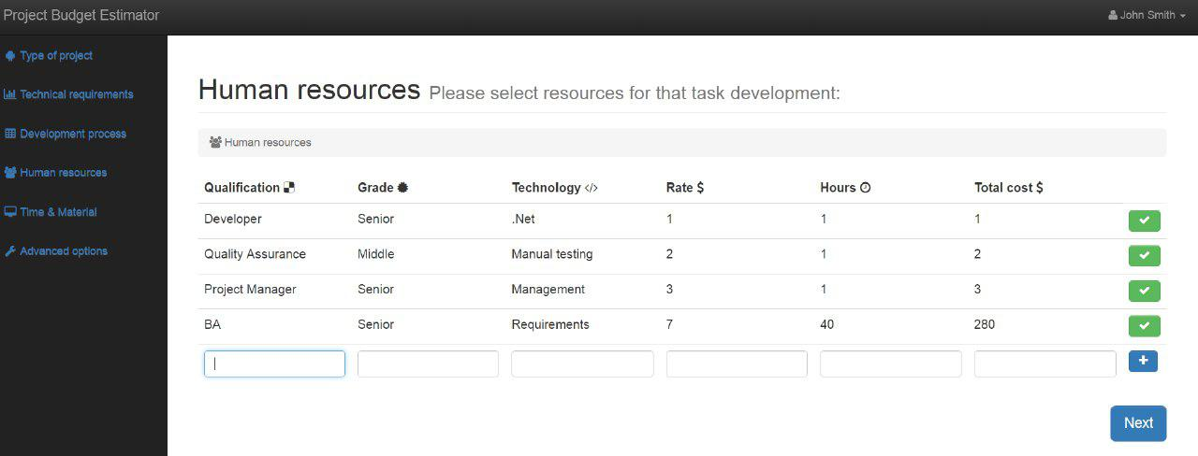

Picture 4.7 – Window of choosing human resources for new project

After user selects human resources, he should chose additional categories that should be developed in the system. It can be as multi-user application, or authorization by social networks, localization, security as 2-step authentication, and so on. Each such additional functionality also impacts on total budget of developed project of feature (see pic. 4.8) ..

jdd

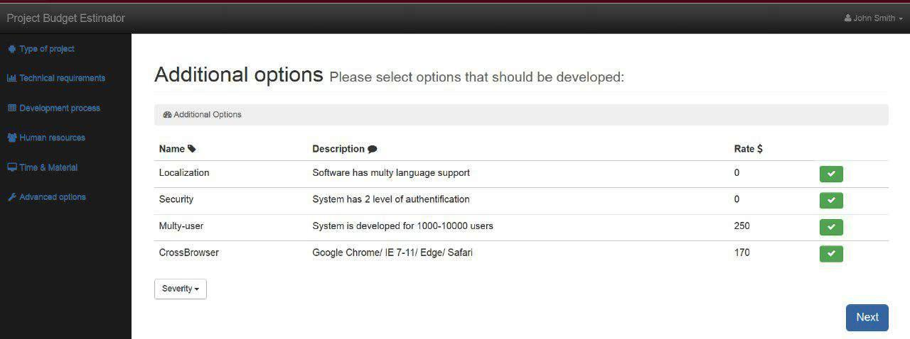

If user did not find any category that should be developed by that project, he can add it to the application by adding attributes. As such category is unknown; application will estimate it higher that provided ones. Anyway, it is better to add unknown items to the system, this way estimations will be much accurate. Picture 4.8 shows the software implementation of the code to work with categories.

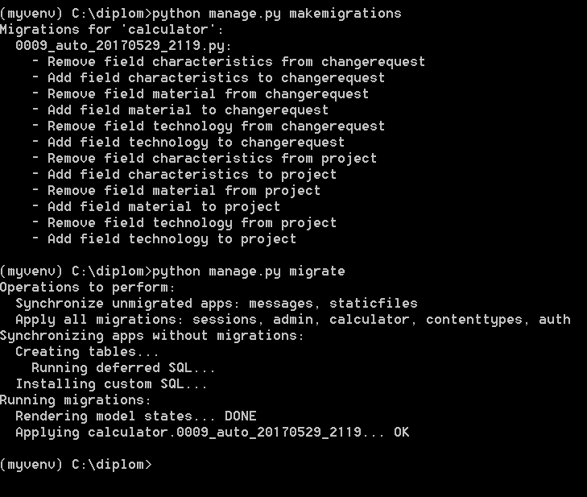

Picture 4.8– Server part of adding new categories

After user selects additional options, he will be redirected to the page with total calculations. There he can add or remove those categories or human resources if he considers that total project cost is much higher that he can afford. To remove selected category, user should click on checkbox. This action will remove selected items from total calculations and total cost will be changed (see pic. 4.9).

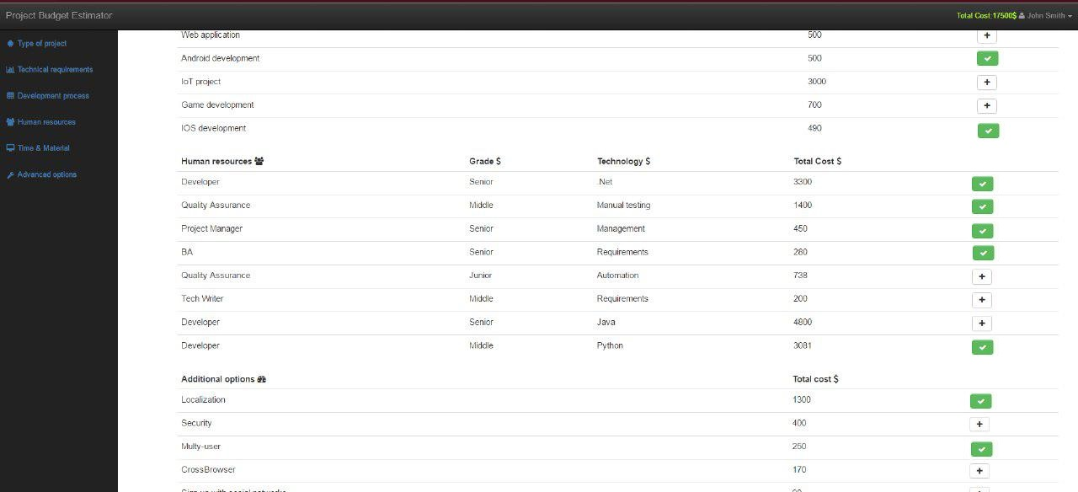

Picture 4.9 – Window of total calculations for new project

The next step, when all changes we made is to save estimations of projects value into application. After user presses on button Submit, calculations for current project will be saved and there will be a possibility to see in View projects history page. There user can see only those projects that were made by him. In addition, from that time user can add change requests to that projects, as from that time it exists in application data base. (see pic. 4.10)

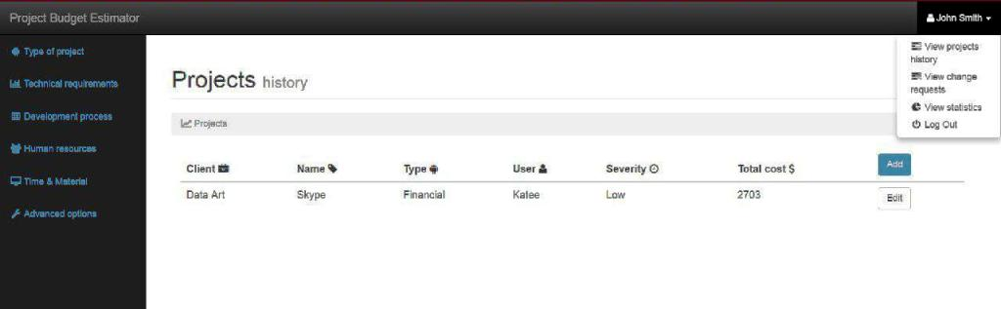Picture 4.10 – View projects history page

Algorithm of adding change request is the same as adding estimations for new project. The main difference is that on the main page user has to select project that should be modified by new change request.

This way project type, clients name will be linked to new change request. Also one more thing that should be highlighted: if user does not save estimations for change request after submitting all required fields, calculation will not affect total cost of project that connects to that change request (see pic.4.11).

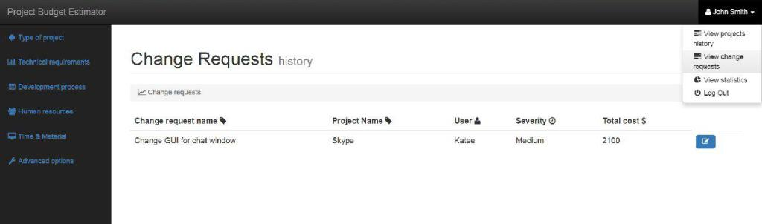

Picture 4.11- View change requests history page

After submitting change request or project they can be modified. For this user should to click on edit button.

5 RESEARCH AND ANALYSIS OF EXPLOITATION AND POSSIBLE USAGE OF APPLICATION

5.1 Analysis of possible usage of application

During graduation work, the web application was designed for sales, project managers for one of IT companies to quickly forecast on-site estimates for products value under its modifications. Accurately estimating project costs is crucial to staying within budget. Get estimate wrong and company could end up in the red or even unable to complete the project. Accurately calculating project costs requires detailed planning and accurate information, plus the ability to foresee potential complications. The same process applies whether the project is building a new website or a multi-story office building. The software application should allow users to get a rough idea of what it will take to change some features in product. It also should have capabilities for estimating the costs for individual project pieces and adding them together to reach a project total. The pieces can differ in size and number from a few large phases of a project with known costs to hundreds or thousands of small tasks. Such categories should be a part of estimation as material, human resources and other costs needed to complete a construction project. In addition there should be a possibility to do all the calculations, so once all the data is entered in, the user will get the total estimated project cost. This application suits for management needs to assess the accuracy of cost estimates and budgets.

The software that will be developed, should have the following functionality:

* possibility of adding estimates to new project or change request;
* possibility of choosing categories (types of project, time & material, human resources, etc.;) that affect project or change request;
* possibility of editing total budget by excluding or including any categories;
* possibility of saving project budget estimation;
* possibility of reviewing history of all change requests that were made to selected project.

Developed web application is focused on using it as in one IT company or in different ones. Management needs to assess the accuracy of cost estimates and budgets. Unanticipated expenses can result in the project being abandoned.

5.2 Description of system testing

To evaluate system performance and identifying and correcting errors were tested. Software testing - a technique quality control verifies compliance between actual and expected behavior programs through the final set of tests which are selected a certain way. There are many approaches for software testing, but effective one is testing of complex products - this is essentially a research process, not only the creation and execution of routine procedures.

Software testing was provided for evaluation system performance, identifying and fixing issues that were in project. Software testing is an investigation conducted to provide stakeholders with information about the quality of the product or service under test. Software testing can also provide an objective, independent view of the [software](https://en.wikipedia.org/wiki/Software) to allow the business to appreciate and understand the risks of software implementation. Test techniques include the process of executing a program or application with the intent of finding [software bugs](https://en.wikipedia.org/wiki/Software_bug) and verifying that the software product is fit for use. The purpose of software testing is to indicate if the system under test meets the requirements that guided its design and development and achieves the general result its stakeholders desire. [9]

Testing levels are basically to identify missing areas and prevent overlap and repetition between the development life cycle phases. In software development life cycle models there are defined phases like requirement gathering and analysis, design, coding or implementation, testing and deployment.  Each phase goes through the testing. [1] Hence there are various levels of testing.

The following types of testing as unit, system and integration affect particaullaty some aspects of the defects. Unit testing allows to perform specific verification of modules, methods, functions and classes. This method shows the performance of individual sections of code and allows quickly verify if following completion impact the functional area. After checking the individual functions and operations systems quality assurance goes to the next step. Integration testing is done typically after the unit one. At this stage, some parts of the code and their interaction with each other are verified. System testing is the final stage. System integration testing is a testing where testers basically test that in the same environment all the related systems should maintain data integrity and can operate in coordination with other systems.

There are also the following types of testing methods as "white box" and "black box". In first case, tester has full access to the source code, and can use it independently for testing and identification of errors that were made by developers. The method of "black box" does not allow get an access to the source code, in this case, control is only through user interfaces. These types of testing defined by the level of knowledge of the system.

During the whole process of implementation project budget estimator system, unit testing was performed to quickly identify and eliminate bugs. In addition, integration testing performed at the component level after the development of all core modules was finished. Integration testing conducted by "top down", that initially tested components of top-level hierarchy objects using stubs instead of lower-level components. When development was finished, smoke testing was performed of whole functionality to eliminate and correct errors.

In addition, significant attention was paid to functional testing, which was conducted with the aim to assure that the system allows the user to solve all the necessary tasks within the declared capabilities of the system. It was also tested the usability of software for further use. However, product testing at this stage only was limited only by alpha testing without involving end users. During testing, it was found that the system works correctly and according to the problem statement. System allows user to add new estimations for new projects or change requests; add new characteristics; view statistics.

In conclusions, after provided testing, it was found that all system functions work correctly, as it was declared.

CONCLUSIONS

During the graduation work was partly designed and developed a software system that has become a handy tool for automated estimation projects value under its modifications.

At the beginning of an analysis domain, during which been reviewed the features and necessity of account for funds. It analyzed existing analog systems intended for maintenance planning and budgeting and identified their main features and drawbacks. The analysis was carried domain problem statement.

In conclusions, such scope was done during graduation work:

* analysis, UML modeling and conceptual domain;
* developed database schema;
* developed algorithms for forecasting estimation of project value under its modifications;
* implemented software application of estimation project’s value including its change requests.

The product provides basic functions that have been described during the formulation of the problem. Created software is useful for sales managers who need to estimate briefly project’s value under its modifications.

It is also necessary in the future improvement of the product by adding new features and creating a system for mobile platforms.

As a result of graduation work, abstract were published, promo video and a presentation were created.

References

1. Black R. Foundations of Software Testing - ISTQB® Certification, 3rd ed.,[Text] / Rex Black, Erik Van Veenendaal,  Dorothy Graham - Cengage Learning, 2012
2. Cockburn A. Writing effective use cases [Text] / Alistair Cockburn Humans and Technology pre-publication published by Addison-Wesley, c. 2001.
3. Dietrich R. Cost Estimation and Project Budgeting [Electronic resource] / R. Dietrich - Mode of access: www/URL: <http://smallbusiness.chron.com/cost-estimation-project-budgeting-25538.html> - Last access: May 15, 2017. – Title from the screen.
4. Django documentation [Electronic resource] django.com: Django guidelines - Mode of access: www/URL: <https://docs.djangoproject.com/en/> - Last access: May 15, 2017. – Title from the screen.
5. García-Fernández L. E. Modeling Strategic Decisions Using Activity Diagrams to Consider the Contribution of Dynamic Planning in the Profitability of Projects Under Uncertainty [Text]/ L.E. García-Fernández and M. Garijo - IEEE - Transactions on Engineering Management, 2010, 57(3), pp. 463-476
6. Guido van R. Python Software Foundation [Text] / van Rossum, Guido - 27 June 2009, -567p
7. Holgeid K. A Reflection on Why Large Public Projects Fail. [Electronic resource] / K. Holgeid M. Thompson – Mode of access: www/URL: <https://www.jbs.cam.ac.uk/fileadmin/user_upload/programmes/emba/downloads/A_Reflection_on_Why_Large_Public_IT_Projects_Fail_Kjetil__Mark_Thompson_s_chapter.pdf> - Last access: May 20, 2017. – Title from the screen.
8. Lukianova K. Yu. Methods of forecasting of changes in product’s value under its modifications in agile projects. [Text]/ K. Yu. Lukianova/ Zbiór artykułów naukowych. Konferencji Miedzynarodowej Naukowo-Praktycznej - Inżynieria i technologia. Nowoczesne badania podstawowe i stosowane (29.04.2017 - 30.04.2017) - Warszawa: 2017. – 6-8 pp. - ISBN: 978-83-65608-56-7
9. Miller E. F. Introduction to Software Testing Technology, Tutorial: Software Testing & Validation Techniques, Second Edition [Text] / E.F. Miller - IEEE Catalog No. EHO 180-0, pp. 4-18
10. Milles R. A Pragmatic Introduction to UML. Learning UML 2.0 [Text] / R. Milles, K. Hamilton, O'REILLY, April 2006, pp. 15-90.
11. Niazi A. Product Cost Estimation: Technique Classification and Methodology Review. [Text]/ A. Niazi; J.S. Dai; S. Balabani; and L. Seneviratne - Journal of Manufacturing Science and Engineering, 2006, 128(2006), pp. 563-575
12. Project Management Institute. A Guide to The Project Management Body of Knowledge [Text] / PMBOK (r) Guide – Fourth edition, Project Management Institute, pmi.org, 2008, [GMProduct=00101095501](http://marketplace.pmi.org/Pages/ProductDetail.aspx?GMProduct=00101095501)
13. SQLite documentation [Electronic resource] sqlite.com: SQLite tutorial - Mode of access: www/URL: <https://www.tutorialspoint.com/sqlite/> - Last access: May 15, 2017. – Title from the screen.
14. Standish Group 2015 Chaos Report - Q&A with Jennifer Lynch [Electronic resource] – Mode of access: www/URL: <http://www.infoq.com/articles/standish-chaos-2015> - Last access: April 20, 2017. – Title from the screen.
15. Usmani F. Tools to Estimate Costs in the Project Management [Electronic resource] / F. Ushmani - Mode of access: www/URL: <https://pmstudycircle.com/2012/06/4-tools-to-estimate-costs-in-the-project-management/> - Last access: May 15, 2017. – Title from the screen.

Appendix А

Presentation slides



Picture А.1 – Title slide

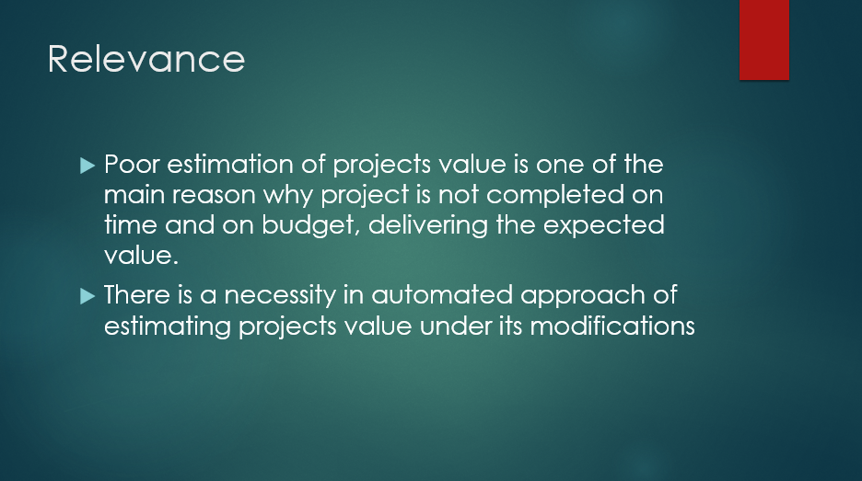

Picture А.2 – Slide «Relevance»

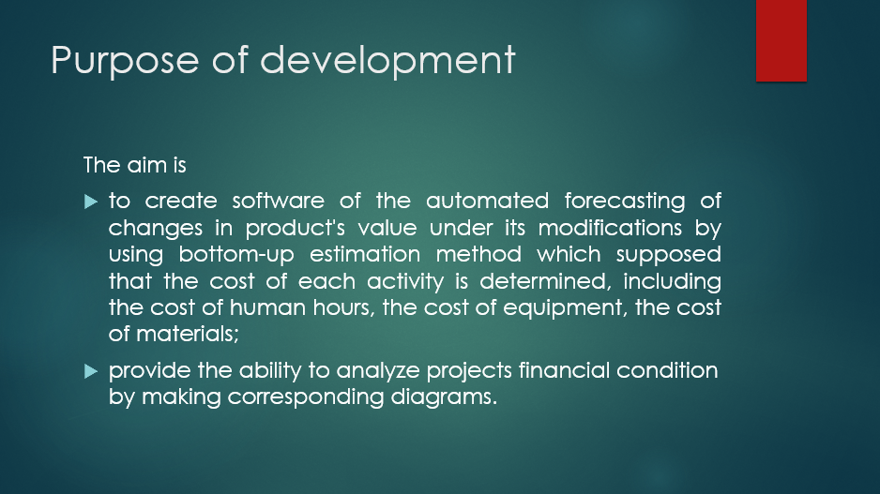

Picture А.3 – Slide «Purpose of development»

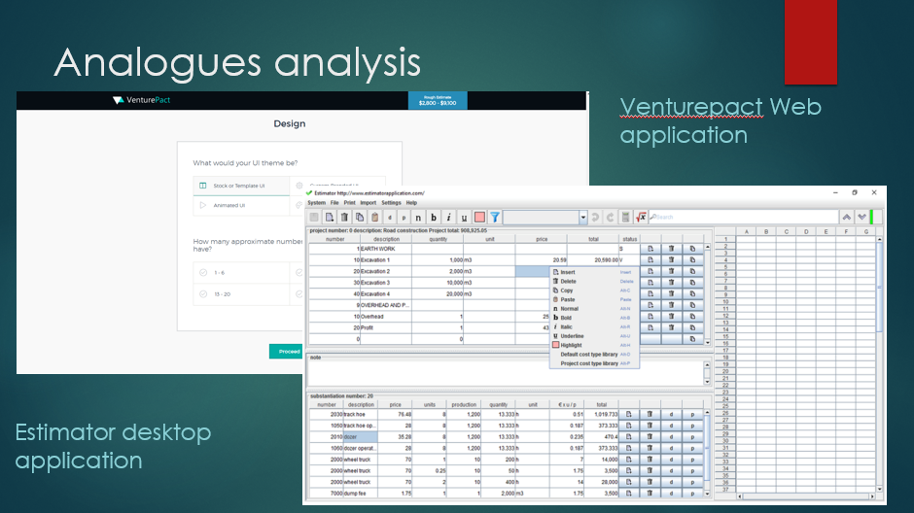

Picture А.4 – Slide «Analogues analysis»

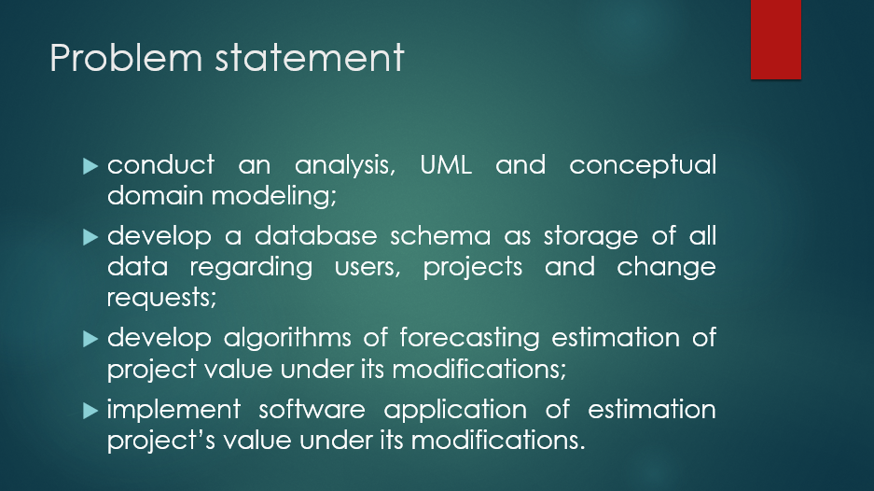

Picture А.5 – Slide «Problem statement»

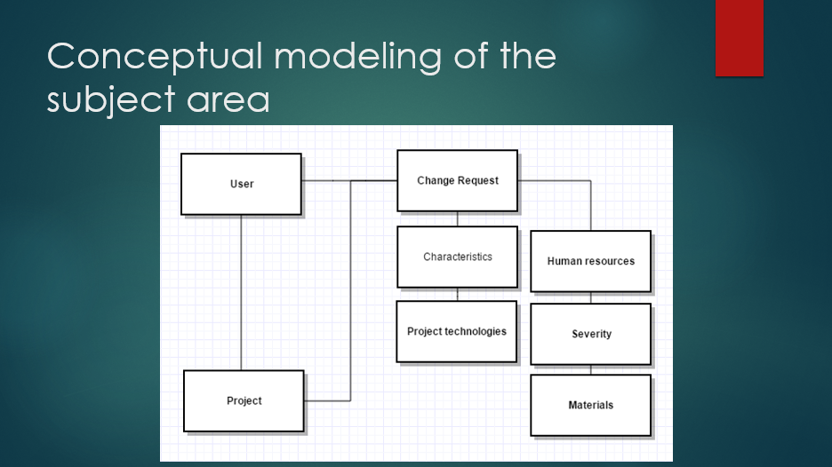

Picture А.6 – Slide «Conceptual modeling of the subject area»

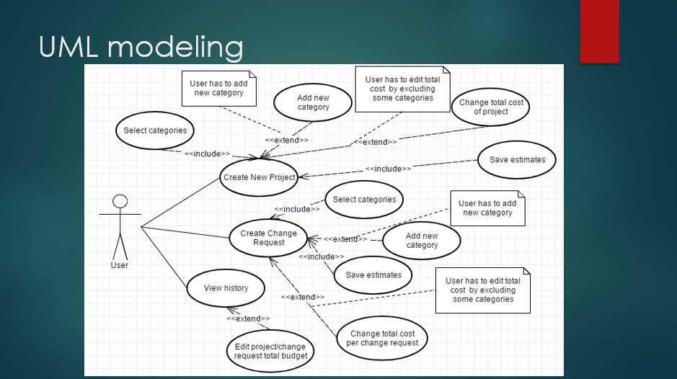

Picture А.7 – Slide «UML-modeling»

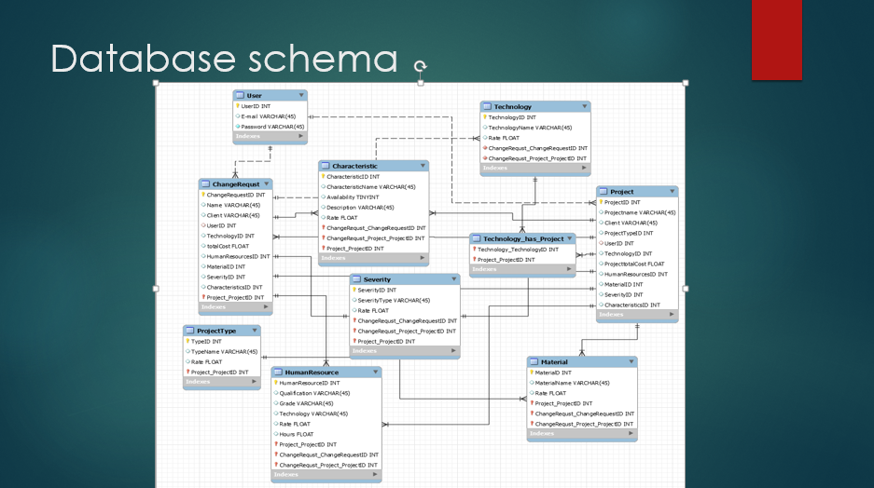

Picture А.8 – Slide «Database schema»

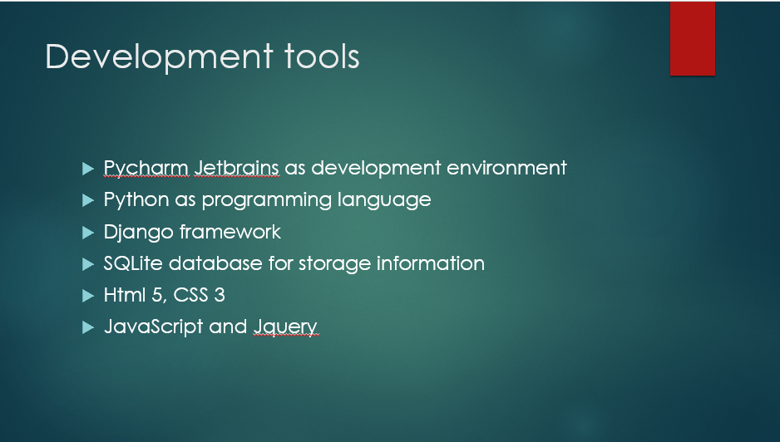

Picture А.9 – Slide «Development tools»

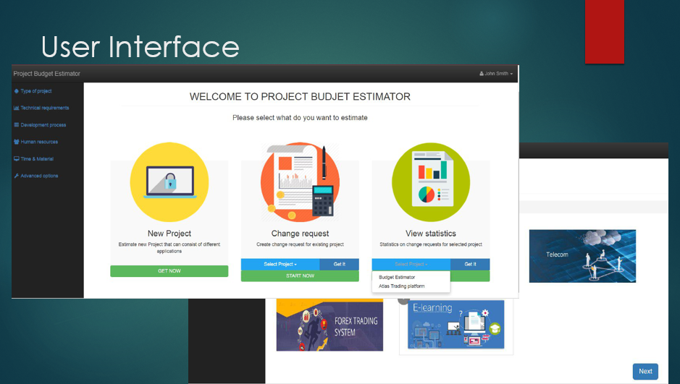

Picture А.10 – Slide «User Interface»

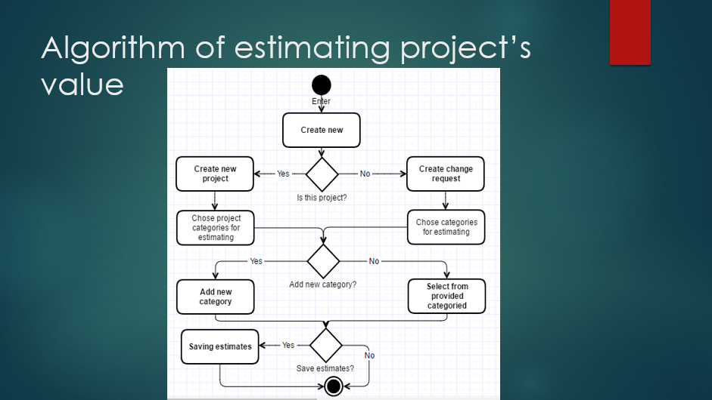

Picture А.11 – Slide «Algorithm of estimating project’s value»

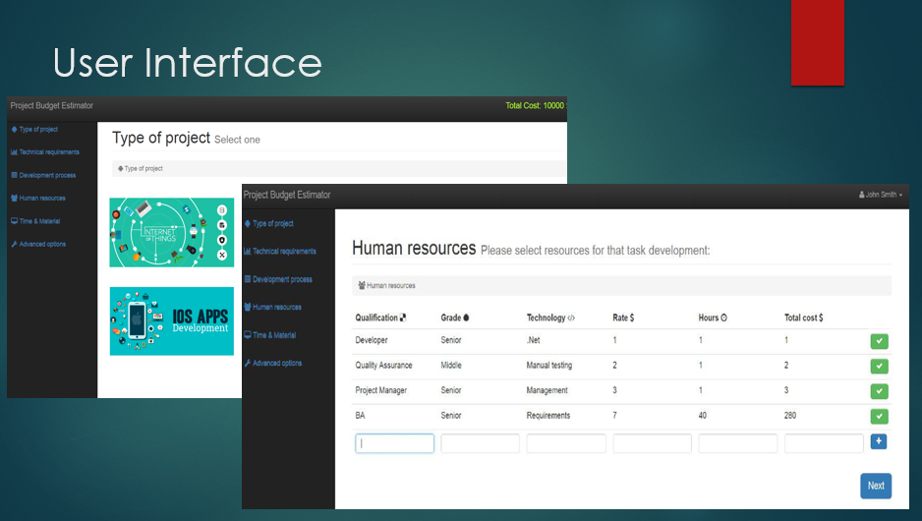

Picture А.12 – Slide «User Interface»

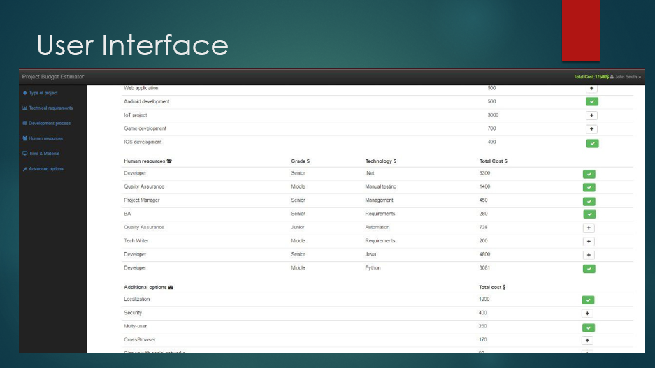

Picture А.13 – Slide «User Interface»

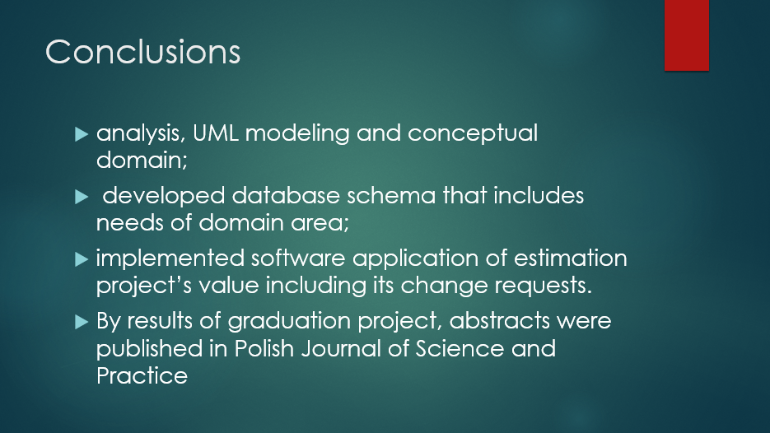

Picture А.14 – Slide «Conclusions»

APPENDIX B

Abstracts to polish journal of Science and Practice

**SUB-SECTION -3. Computer Science, Computing and automation**

**Kateryna Yu. Lukianova**

Student

of Kharkiv National University

of Radioelectronics,

Software Engineering Department

**METHODS OF FORECASTING OF CHANGES IN PRODUCT'S VALUE UNDER ITS MODIFICATIONS IN AGILE PROJECTS.**

*These abstracts are devoted to find most optimal method of forecasting of changes in product's value under its modifications in Agile projects.*

**Keywords: Agile, budget estimation, forecasting techniques, software requirements.**

**Problem statement and its relation to practical-research tasks.** Nowadays in IT industry more and more projects, startups and variety of products are being developed, but not all of them are successfully released. In term of project success, is the product that is completed on time and on budget, delivering the expected value. The main reason of failure projects is poor cost estimation. As software costs estimation is inherently difficult, and humans are terribly bad at predicting absolute outcomes. No two projects are the same: each is unique in what it sets out to achieve. Often, when appears a simple problem during development it is much harder or technically challenging to implement it without cost changing. Undoubtedly, there will be ‘unknowns’ with the project that can only be identified when they arise.

Moreover, no two people are the same, whether you’re a customer, a developer or a user. We come preloaded with our own set of knowledge, experiences, values, expectations, attitude to risk, and ability to adapt.

Nevertheless, there are some forecasting techniques that helps to estimate product cost and in this paper, we are going to find out the most suitable one for majority Agile projects.

**References analysis.** In their 2015 Chaos Report, The Standish Group, in their assessment of more than 50,000 projects, found that less than 29% of projects were successful (i.e. on time, on budget and, completed as planned). More concerning is the finding that as many as 19% of all projects fail outright (Pic. 1) [3].

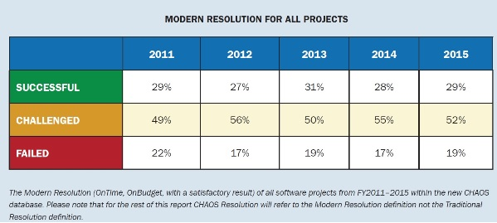

Pic.1 – Modern resolution for all projects

From this, we can see that accurate product cost estimating is very important. Underestimated budget may convince management to develop new systems that later over run their budgets and fail to achieve their expected payoff. Many worthwhile projects are cancelled because of cost overruns due to poor estimates [1]. This way company loses its profit in both aspects: future cooperation with client and unreleased product.

On other hand, overestimated costs may convince management not to develop potentially beneficial systems. When estimators predict unrealistically high costs beyond the maximum permitted to justify a new system with major benefits, management generally declines to approve it and thus loses those potential benefits.

In order to plan the budget for a project, many costs are not known in advance.  This way forecasting is used in order to estimate what these costs will be.  Forecasts can never be completely accurate, but can provide a good idea of what to expect if the appropriate techniques are used.  Some forecasting techniques are less accurate than others but are used to start off planning.  When more detailed data becomes available, more accurate forecasting techniques can be used [2].  This paper helps to get through forecasting techniques and their benefits and limitations.

**Formulation of research objectives.** Based on the previously mentioned, the purpose of this article is to find out the most suitable forecasting method of changes in product's value under its modifications in Agile projects.

In the forecasting budget process, the cost of each project activity is estimated. In forecasting budget process, the cost of each activity is determined, including the cost of human hours, the cost of equipment, and the cost of materials used as well as the contingency cost (i.e. the cost to cover the identified risks) [2].

Do not forget about risks, cause due to this factor project overruns budget and time in most of cases.

In this paper, we are going to go through three forecasting techniques to estimate costs in project:

* Analogous Estimating
* Three Point Estimating
* Bottom up Estimating

These four estimation methods represent a hierarchical structure where Analogous Estimating is the least accurate method, and Bottom-up Estimating is the most accurate method.

**Analogous Estimating**

This technique is used to estimate the project cost when very little detail about the project is available. Therefore, this technique does not provide a very reliable estimation. The primary benefits of this technique are its lower cost and quick results.

In Analogous Estimation, the cost of the project is estimated by comparing it with similar projects previously completed by your organization. However, the reality is that there is no two identical projects: what suits to one may not fit to another.

**Three-Point Estimating**

This forecasting technique is used to reduce the uncertainties in estimating assumptions. Instead of finding one estimate, three estimates are determined and then their average is taken to reduce the risks and biases.

PERT (Program Evaluation and Review Technique) is the most commonly used method in three-point estimation technique.

Three PERT estimates are as follows:

* **Most Likely Cost (Cm):** Considers a normal case and everything goes as usual.
* **Pessimistic Cost (Cp):** Considers the worst case and assumes that almost everything goes wrong.
* **Optimistic Cost (Co):** Considers the best case and assumes that everything goes better than planned.

PERT Estimate formula is:

 (1)

Where, Ce = Expected Cost

Estimates derived from this technique are better than the two techniques presented earlier because it reduces the biased view from the data and provides a more accurate estimate.

**Bottom-up Estimating**

This forecasting technique is the most accurate, time-consuming, and costly technique for estimating the cost. For this forecasting method, it is better to use WBS project. There you can obviously realize how much time and cost should be done by the end of whole project. As by WBS the total work is divided into the smallest work components, where each component cost is estimated and only then you get the project cost estimation.

**Conclusions**. By the results of the research in this paper it is important to note that the more accurate a method, the costlier and time consuming it becomes. This way, it is not always advisable to use Bottom-up Estimating when you are short on time or resources, even though it might be the most accurate.

Although, it is need to remember that there is no metrics that help to predefine correct budget that will fit to majority of software products.

**References.**

1. Holgeid K., Thompson M. A Reflection on Why Large Public Projects Fail. [Electronic resource] – Access mode: <https://www.jbs.cam.ac.uk/fileadmin/user_upload/programmes/emba/downloads/A_Reflection_on_Why_Large_Public_IT_Projects_Fail_-_Kjetil__Mark_Thompson_s_chapter.pdf> (Accessed date: April 8, 2017)
2. Project Management Institute. A Guide to The Project Management Body of Knowledge - PMBOK (r) Guide – Fourth edition, Project Management Institute, pmi.org, 2008, [GMProduct=00101095501](http://marketplace.pmi.org/Pages/ProductDetail.aspx?GMProduct=00101095501)
3. Standish Group 2015 Chaos Report - Q&A with Jennifer Lynch [Electronic resource] – Access mode: <http://www.infoq.com/articles/standish-chaos-2015> (Accessed date: April 19, 2017)

APPENDIX C

Code Listing

Here is a code example with working with database

lass Characteristics(models.Model):

name = models.CharField(max_length=100)

availability = models.BooleanField

description = models.CharField(max_length=500)

rate = models.IntegerField(default=0)

def __str__(self):

return "%s" % self.name

class Meta:

verbose_name = "Characteristic"

verbose_name_plural = "Characteristics"

class Severity(models.Model):

type = models.CharField(max_length=200)

rate = models.IntegerField(default=0)

def __str__(self):

return "%s" % self.type

class Meta:

verbose_name = "Severity"

verbose_name_plural = "Severities"

class Materials(models.Model):

type = models.CharField(max_length=200)

rate = models.IntegerField(default=0)

def __str__(self):

return "%s" % self.type

class Meta:

verbose_name = "Material"

verbose_name_plural = "Materials"

class HumanResources(models.Model):

qualification = models.CharField(max_length=200)

grade = models.CharField(max_length=200)

technology = models.CharField(max_length=200)

rate = models.IntegerField()

hours = models.IntegerField()

total_cost = models.IntegerField(default=0, editable=False)

def __str__(self):

return "%s %s %s" % (self.id, self.qualification, self.grade)

class Meta:

verbose_name = "HumanResource"

verbose_name_plural = "HumanResources"

def save(self, *args, **kwargs):

self.total_cost = self.rate * self.hours

super(HumanResources, self).save(*args, **kwargs)

class Technologes(models.Model):

name = models.CharField(max_length=200)

rate = models.IntegerField()

def __str__(self):

return "%s" % self.name

class Meta:

verbose_name = "Technology"

verbose_name_plural = "Technologies"

class Type(models.Model):

name = models.CharField(max_length=100)

rate = models.IntegerField(default=0)

def __str__(self):

return "%s" % self.name

class Meta:

verbose_name = "Type"

verbose_name_plural = "Types"

class Project(models.Model):

client = models.CharField(max_length=100)

name = models.CharField(max_length=200)

type = models.ForeignKey(Type)

technology = models.ManyToManyField(Technologes)

user = models.CharField(max_length=200)

humanResources = models.ManyToManyField(HumanResources)

severity = models.ForeignKey(Severity)

characteristics= models.ManyToManyField(Characteristics)

material = models.ManyToManyField(Materials)

totalCost = models.IntegerField(default=0, editable=False)

def __str__(self):

return "%s" % self.name

class Meta:

verbose_name = "Project"

verbose_name_plural = "Projects"

def save(self, *args, **kwargs):

total = 0

total += self.type.rate

total += self.severity.rate

TechList = self.technology.all()

for technology in TechList:

total += technology.rate

Charactlist = self.characteristics.all()

for charact in Charactlist:

total += charact.rate

MaterialList = self.material.all()

for material in MaterialList:

total += material.rate

HRlist = self.humanResources.all()

for HRcost in HRlist:

total += HRcost.total_cost

self.totalCost = total

super(Project, self).save(*args, **kwargs)

class ChangeRequest(models.Model):

project = models.ForeignKey(Project)

name = models.CharField(max_length=200)

technology = models.ManyToManyField(Technologes)

user = models.CharField(max_length=200)

humanResources = models.ManyToManyField(HumanResources)

severity = models.ForeignKey(Severity)

characteristics = models.ManyToManyField(Characteristics)

material = models.ManyToManyField(Materials)

totalCost = models.IntegerField(default=0, editable=False)

def __str__(self):

return "%s %s" % (self.id, self.name)

class Meta:

verbose_name = "Request"

verbose_name_plural = "Requests"

def save(self, *args, **kwargs):

total = 0

total += self.severity.rate

TechList = self.technology.all()

for technology in TechList:

total += technology.rate

Charactlist = self.characteristics.all()

for charact in Charactlist:

total += charact.rate

MaterialList = self.material.all()

for material in MaterialList:

total += material.rate

HRlist = self.humanResources.all()

for HRcost in HRlist:

total += HRcost.total_cost

self.totalCost = total

super(ChangeRequest, self).save(*args, **kwargs)